Predictive Modeling Using Machine Learning on Titanic Dataset
Name
Dharani Dharan S
Internship
Data Science Internship

1. Objective
The objective of this project is to build a machine learning model that can predict whether a passenger survived the Titanic disaster based on various passenger attributes. This project demonstrates the use of supervised machine learning techniques, model training, testing, and performance evaluation.

2. Dataset Description
The Titanic dataset contains information about passengers aboard the Titanic ship. The dataset includes features such as passenger class, gender, age, fare, and survival status.
Dataset Features
- Passenger Class (Pclass)
- Gender (Sex)
- Age
- Fare
- Survival Status (Survived)
Dataset Size
- Total Records: 891
- Total Columns: 12

3. Tools and Technologies Used
- Python
- Google Colab
- Pandas
- Scikit-learn
- Matplotlib
- Seaborn

4. Data Preprocessing
Before training the model, the dataset was cleaned and prepared.
Steps Performed
- Loaded the Titanic dataset.
- Handled missing values in the Age column using the median value.
- Handled missing values in the Fare column.
- Converted categorical data (Gender) into numerical format.
- Selected relevant features for model training.
- Split the dataset into training and testing datasets.

5. Machine Learning Algorithm Used
Random Forest Classifier
Random Forest is a supervised machine learning algorithm that combines multiple decision trees to improve prediction accuracy and reduce overfitting.

Advantages
- High accuracy
- Handles large datasets efficiently
- Reduces overfitting
- Suitable for classification problems

6. Model Training and Testing
The dataset was divided into two parts:
- Training Data: 80%
- Testing Data: 20%
The Random Forest Classifier was trained using the training dataset and evaluated using the testing dataset.

7. Model Accuracy
After training and testing the model, the following accuracy was obtained:
Accuracy Score
Accuracy = 0.7932960893854749

8. Confusion Matrix
A confusion matrix was used to evaluate the performance of the machine learning model.
The confusion matrix shows:
- True Positives
- True Negatives
- False Positives
- False Negatives

Confusion Matrix Output:

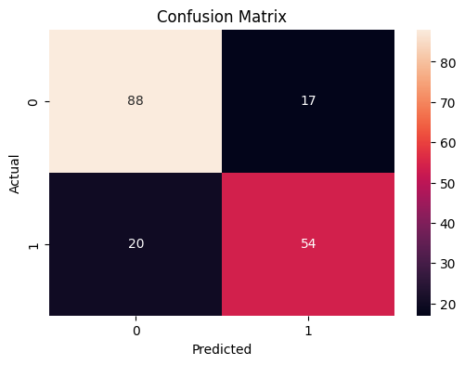

9. Results and Findings
The machine learning model successfully predicted passenger survival based on selected features.
Key Findings
- Passenger gender significantly influenced survival chances.
- First-class passengers had a higher probability of survival.
- Age and fare also contributed to survival prediction.
- Random Forest provided good classification performance.

10. Conclusion

- This project successfully implemented a machine learning model using the Titanic dataset. Data preprocessing, model training, testing, and evaluation were performed using Python and Scikit-learn.

- The Random Forest Classifier achieved satisfactory accuracy and demonstrated how supervised machine learning techniques can be used to predict outcomes from real-world data.

- This project enhanced understanding of machine learning concepts such as classification, model evaluation, accuracy measurement, and confusion matrix analysis.

